**Scan QR Code App Demo Instruction**

1. Install the APK:
   1. Locate the APK file you received or downloaded.
   2. Transfer the APK file to your device, either through USB or any other method you prefer.
   3. On your device, navigate to the location where the APK file is stored.
   4. Tap on the APK file to begin the installation process.
   5. Follow the on-screen instructions to complete the installation.
2. Open Glassmate and connect with Glass 2 Dock:
   1. Ensure that your Glass 2 device is powered on and connected to the Glass 2 Dock.
   2. Launch the Glassmate app on your device.
3. Import the folder into "My Files":
   1. Locate the folder provided within the downloaded zip folder.
   2. Transfer the folder to your device, either through USB or any other method you prefer.
   3. Open the Glassmate app on your device.
   4. Within the app, navigate to the "My Files" section.
   5. Import the folder you transferred into the "My Files" section of the Glassmate app.

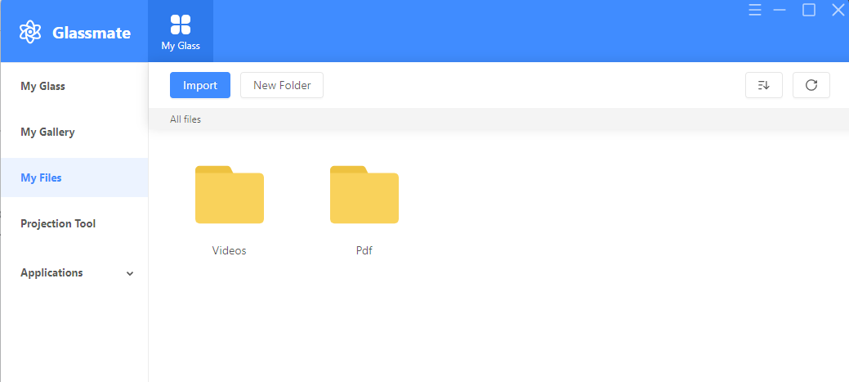

1. Start the app:
   1. Within the Glassmate app, locate and tap on the app you installed in step 1.
   2. The app will launch and be ready for use.
2. Scan QR Codes:
   1. Within the app, either tap on the "Start Scan" button or use voice command by saying "Start Scan".
   2. Aim the camera of your Glass 2 device at one of the provided QR Codes.
   3. Allow the app to scan and process the QR Code.
   4. Depending on the scanned QR Code, the app will display the corresponding file (video or PDF) on the bottom of the QR Code.

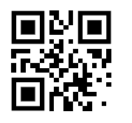

Video1(GEA Grasso Screw Compressor Product Animation-wqNTYLIDaxs-720p-1654246055390.mp4)



Video2(Gas Compressor Package.mp4)



Video3(Rolls-Royce How Engines Work-JxkJ-FwFeVI-720p-1654417847380.mp4)



Pdf1(GEA Screw Compressor Package Brochure.pdf)



Pdf2(grasso-screw-compressor-package-pi_tcm26-38504.pdf)

1. Navigate back:
   1. To navigate back to the previous interface use the voice command by saying "navigate back".